**Yellow**

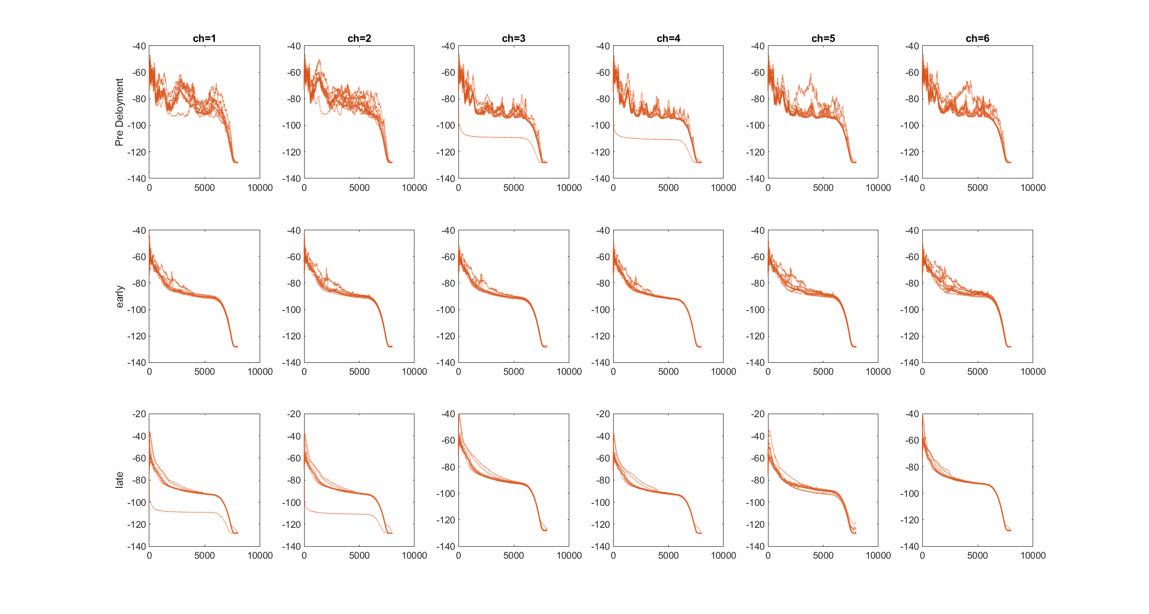

*Notes:*

The top two channels seem to be louder than the others in all early and some late recordings

|  |  |  |  |
| --- | --- | --- | --- |
| Recording no | Pre | Early | Late |
| 1 | 3+4 Down  low noise  Cars, LOADS of birds | Signal on all channels  Moderate noise  Pigeon | Signal on all channels  Moderate/low noise  Crow and helicopter |
| 2 | Signal on all channels  Moderate noise  Chainsaw (?) Bit creepy – very Ari Aster. Some high trills | Signal on all channels  Moderate noise  Helicopter | Signal on all channels  Moderate/low noise  Bird trills |
| 3 | Signal on all channels  Moderate noise (low tinny grumbles)  Bird calls | Signal on all channels  Moderate noise  Bird chirps | Signal on all channels  Moderate/low noise  Bird calls identifiable |
| 4 | Signal on all channels  Low/moderate noise  Wind and chainsaws | Signal on all channels  Moderate/low noise  Plane sound | Signal on all channels  High noise  Rain and strong wind |
| 5 | Signal on all channels  Grumbly noise (possibly rain)  Plane, birds, grumbles | Signal on all channels  Moderate noise  Bird call | Signal on all channels  Moderate noise  Parakeets and wind |
| 6 | Signal on all channels  Noise and grumbles  Chainsaw, pigeons, tweets | Signal on all channels  Moderate/medium noise  Plane sound very clear | First two channels dead  Moderate noise  Bird chirps |
| 7 | Signal on all channels  Moderate noise  Car and chainsaws | Signal on all channels  Moderate noise  Child/ bird trills | Signal on all channels  Moderate/high noise  Lots of wind |
| 8 | Signal on all channels  Moderate noise  Rain and distant birdcall | Signal on all channels  Moderate/Low noise  Plane | Signal on all channels  Moderate noise  Magpie call |
| 9 | Signal on all channels  Grumbly noise  Parakeets | Signal on all channels but quiet  Moderate/low noise  Logging sounds (I think) | Signal on all channels  Moderate noise  Parakeets |
| 10 | Signal on all channels  Grumbly noise  Wind gusts, pigeons, other tweeting birds | Signal on all channels really lous  Moderate/low noise  LOUD logging sounds and bird calls | Signal on all channels  Moderate noise  Parakeets |

**Yellowgreen**

*Notes:*

First two channels are **considerable louder** in late in all early **and** late recordings

There also seems to be a band of signal in all the late recordings at around 1kHz (just top 2 channels)

|  |  |  |  |
| --- | --- | --- | --- |
| Recording no | Pre | Early | Late |
| 1 | Signal on all channels  Low noise  Bird chattering and chainsaws | Signal on all channels (1+2 louder)  Moderate/high noise  Distant calls | Signal on all channels  Noise moderate  3-6 appear to be just noise while 1+2 have definite calls but a weird band of noise |
| 2 | Signal on all channels  Moderate noise  Some trills + chainsaw | Signal on all channels (first 2 way louder)  Moderate noise  Maybe chainsaws? | Signal on all channels  3-6 very quiet  Logging and bird calls |
| 3 | Signal on all channels  Moderate noise (low grumbles)  Bird chirps | Signal (ish) on all channels  Moderate noise  Bird chirps and stuff in the first 2 channels | Signal on all channels  3-6 very quiet again  But magpies detectable on all channels |
| 4 | Signal on all channels  Moderate noise and grumbles (maybe rain)  Chirps and trills | Signal on all channels (first 2 way louder)  Moderate noise  Planes and birds in the first 2 | Signal on all channels 3-6 are very quiet  Possible bird calls? |
| 5 | Signal on all channels  Moderate/high noise (grumbles)  Saw? Some cheeps? |  | Signal on all channels  3-6 very quiet  Bird calls in ch1+2 |
| 6 | Signal on all channels  Moderate/high noise  Chainsaw? |  |  |
| 7 | Signal on all channels  Moderate noise (grumbles)  Clear cheeps + a crow |  |  |
| 8 | Signal on all channels  Quite noisy  Quiet aside from chainsaw + some cheeps |  |  |
| 9 | Signal on all channels moderate grumbly noise  Cheeps and chainsaw, pigeon? |  |  |
| 10 | Signal on all channels  Moderate noise  Chainsaw, parakeets, cheeps and trills |  |  |

**Green**

*Notes:*

2 seems to be the most sensitive to noise AND signal in the later recordings. Channel 2 could detect bird calls/ trills much clearer than the other microphones.

|  |  |  |  |
| --- | --- | --- | --- |
| Recording no | Pre | Early | Late |
| 1 |  |  | Signal on all channels  Moderate noise  Parakeets and other high calling birds detectable |
| 2 |  |  | Signal on all channels  1+2 dead until 4:30  4 low freq noise until 4:30  Moderate noise  Plane and maybe bird detectable |
| 3 |  |  | Signal on all channels  2 louder noise  Moderate noise  Bird trills |
| 4 |  |  | Signal on all channels  Noise louder on 2  Moderate noise  Closeby parakeet, planes |
| 5 |  |  | Signal on all channels  Noise louder on 2  Moderate/low noise  Planes, parakeet |
| 6 |  |  | Signal on all channels  Noise louder on 2  Parakeets, cars, loud plane |
| 7 |  |  | Signal on all channels  Moderate/low noise  Dogs, Loud dogs , lots of bird trills |
| 8 |  |  | Signal on all channels  2 clearest  Moderate noise  Bird trills |
| 9 |  |  | Signal on all channels  Moderate noise  Magpie, plane, wind |
| 10 |  |  | Signal on all channels  2 loudest  Moderate noise  Bird trills |

**Blue**

*Notes:*

Noise in the late recordings seems a higher pitch than in yellow

Seems most signals that you can hear above the noise are low freq (signal at around 1kHz)

|  |  |  |  |
| --- | --- | --- | --- |
| Recording no | Pre | Early | Late |
| 1 |  | Channel 3+4 dead  Static noise  Plane | 4+5 dead  Static noise  Only wind? |
| 2 |  | Signal on all channels (quiet)  Static noise  Very quiet – maybe wind | Signal on all channels  1+2 drop out at 6:00  3+4 come in at 6:00  Only wind discernable |
| 3 |  | Channel 3+4 dead  Static noise  Nothing discernable – maybe wind? | 3+4 dead  Moderate noise  Only wind (maybe?) nothing discernable really |
| 4 |  | Signal on all channels  Static noise  Possible calls but nothing discernable | 3+4 dead  Static noise  Plane and wind |
| 5 |  | Signal on all channels  Static noise  Possible calls, discernable plane | 1+2 dead  Static noise  Very low signal? Nothing really detectable |
| 6 |  | 3+4 drop out a minute in  Static noise  Wind only | 5+6 dead  Static noise  Wind? |
| 7 |  | 3+4 dead  Static noise  Nothing discernable | 3+4 dead  Static noise  Definite discernable wind |
| 8 |  | 1+2 dead  Static noise  Wind only | 3+4 dead  Static noise  Definite discernable wind |
| 9 |  | Signal on all channels (4 + 5 drop out at 8:30)  Static noise  Possible calls, definite wind | 5+6 dead  Static noise  Definite discernable wind |
| 10 |  | Signal on all channels  WEIRD  1+2 come back online at the same time 3+4 drop out  Static noise  Nothing discernable | 5+6 dead  Static noise  Definite discernable wind |